**Spring Micro services**

* **What is a Monolith Application?**

Monolith applications are typically huge - more 100,000 line of code. In some instances even more than million lines of code

* Which is released (taken to production) once every few months
* Which has a wide range of features and functionality
* Which has a team of more than 50 working for it
* Where debugging problems is a big challenge
* Where bringing in new technology and new process is almost impossible

**Monoliths are characterized by**

* Large Application Size
* Long Release Cycles
* Large Teams

**Typical Challenges include**

* Scalability Challenges
* New Technology Adoption
* New Processes - Agile?
* Difficult to Automation Test
* Difficult to Adapt to Modern Development Practices
* Adapting to Device Explosion

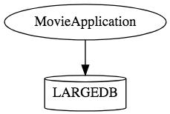

* **Microservices**

Independent small deployed units that work together.

* REST - Built around RESTful Resources. Communication can be HTTP or event based.
* Small Well Chosen Deployable Units - Bounded Contexts
* Cloud Enabled - Dynamic Scaling

